Guidelines for Writing the Proposal: Input, Feature Engineering, Feature Extraction, and Preprocessing

1. Input Data
PhageMatch will rely on a diverse array of biological and metadata inputs to create a robust prediction pipeline. Include the following sources of input data in the proposal:
- Genomic Data:
  - Bacterial genomes (DNA sequences).
  - Phage genomes, with annotations where available.
  - CRISPR spacer sequences from bacterial genomes.
- Proteomic Data:
  - Protein sequences of phages and bacteria, focusing on receptor-binding proteins (RBPs).
  - Annotations of protein domains and structures (using tools like Pfam).
- Phenotypic Data:
  - Growth rate and resistance profiles of bacterial strains.
  - Lytic or lysogenic behavior of phages.
- Environmental Data:
  - Geographic origin of samples.
  - Conditions such as pH, temperature, and nutrient levels.
- Multi-Omics Data:
  - Transcriptomics: Gene expression profiles during phage-host interactions.
  - Epigenomics: Methylation patterns and histone modifications.
  - Metabolomics: Metabolic pathways and host-phage dynamics.

2. Feature Engineering
Feature engineering transforms raw data into meaningful representations for machine learning models. The proposal should emphasize:
- Genomic Features:
  - k-mer Frequencies: Generate overlapping sub-sequences (e.g., 6-mers or 8-mers) from DNA/RNA, calculate their frequency, and use optimized distance metrics (e.g., d2).
  - GC Content: Compute the percentage of guanine and cytosine to assess genomic stability and co-evolution.
  - Codon Usage Bias: Quantify adaptations of phages to bacterial tRNA pools.
  - CRISPR Spacer Matches: Match bacterial spacers to phage sequences to infer interactions.
  - Recombination Hotspots: Detect regions prone to recombination for evolutionary insights.
- Proteomic Features:
  - RBPs: Include sequence motifs, structural details, and domain interactions of RBPs.
  - Amino Acid Composition: Measure amino acid frequencies in phage and bacterial proteins.
  - Physicochemical Properties: Extract features like hydrophobicity, polarity, and molecular weight.
  - Evolutionary Conservation: Highlight conserved regions across RBPs for prediction accuracy.
- Phenotypic Features:
  - Resistance markers and metabolic changes during infections.
  - Bacterial lytic/lysogenic profiles.
- Environmental Features:
  - Incorporate metadata about the geographic and environmental conditions of phage-host ecosystems.

3. Feature Extraction
Feature extraction leverages computational models to automatically derive patterns and embeddings. Include the following:
- Genomic Data:
  - DNABERT: Use for embedding DNA sequences into meaningful vectors.
  - k-mer Embeddings: Apply Word2Vec or FastText to encode relationships between k-mers.
  - Local k-mer Similarity: Identify high-similarity genome segments for interaction prediction.
- Proteomic Data:
  - Protein Language Models: Use ProtBERT or AlphaFold embeddings for structural insights.
  - Secondary Structure Predictions: Annotate alpha-helices, beta-sheets, and coils using PSIPRED.
  - Protein-Protein Interaction Networks: Model phage-bacterial protein relationships with graph neural networks (GNNs).
- Multi-Omics Data Integration:
  - Use contrastive learning or generative models to extract unified embeddings from genomic, transcriptomic, and proteomic data.
  - Combine phenotypic assays and environmental metadata for comprehensive features.

4. Preprocessing
Detail preprocessing steps to ensure clean and structured data for machine learning:
- Data Cleaning:
  - Remove low-quality or incomplete genomic/proteomic entries.
  - Handle noisy or missing data using imputation techniques.
- Dynamic Data Augmentation:
  - Use GANs to generate synthetic phage-host interaction datasets.
  - Create additional genomic or protein sequences to balance class distributions.
- Sequence Alignment and Normalization:
  - Normalize nucleotide/protein sequences (e.g., to fixed lengths with padding).
  - Align sequences using BLAST for comparative analysis.
- Pre-Trained Models:
  - Incorporate embeddings from pre-trained models like ESM or DNABERT directly into feature pipelines.
- Negative Sampling:
  - Avoid random sampling for negative cases. Use partial-matching or fuzzy clustering to create semi-verified non-host datasets.

Additional Notes
- Explain the importance of multi-omics data integration and advanced feature extraction techniques like GNNs and self-supervised learning to ensure the robustness of predictions.
- Include visualization tools such as SHAP for feature importance and Cytoscape for graph analysis to emphasize transparency and explainability.
- Highlight preprocessing innovations like data augmentation and sequence embedding to demonstrate your model's ability to generalize across diverse datasets.

Guidelines for Writing the Proposal: Model Development
This detailed guidance outlines the critical aspects of model development for the PhageMatch application, focusing on how to design and implement advanced predictive models. The proposal should emphasize the integration of state-of-the-art machine learning and deep learning techniques tailored to phage-host interaction prediction.

1. Core Objectives for Model Development
Ensure the proposal highlights the following objectives:
- Accuracy and Precision: Achieve high specificity and sensitivity in predicting phage-host interactions.
- Scalability: Handle large-scale multi-omics data efficiently for global and clinical applications.
- Adaptability: Incorporate novel data (e.g., new phages, bacterial strains) dynamically.
- Explainability: Provide interpretable predictions for clinicians and researchers.

2. Recommended Models and Techniques
Describe the models and technologies for each feature-specific task and their implementation details:
A. Base Predictive Models
- Classical Machine Learning:
  - Random Forests (RF):
    - Use for k-mer similarity-based predictions.
    - Benefits: High interpretability and capability to handle categorical and numerical data.
  - Gradient Boosting Models (e.g., XGBoost):
    - Apply to genomic classification tasks like CRISPR spacer matching and GC content analysis.
    - Benefits: Performs well on imbalanced datasets and offers feature importance insights.
- Deep Learning:
  - Convolutional Neural Networks (CNNs):
    - Task: Analyze amino acid sequences and structural protein features.
    - Example Architecture:
      - Input: Protein embeddings (e.g., ProtBERT).
      - Layers: 3–5 convolutional layers followed by dense layers for classification.
    - Use Case: Identify receptor-binding proteins (RBPs) and structural motifs.
  - Graph Neural Networks (GNNs):
    - Task: Model phage-host ecosystems.
    - Example Implementation:
      - Nodes: Represent phages and bacterial strains.
      - Edges: Encode genomic, proteomic, or phenotypic interactions.
      - Technologies: DGL or PyTorch Geometric.
  - Transformer Models for Phenotypic Data:
    - Replace RNNs with Transformer-based architectures for higher accuracy in time-series data.
- Ensemble Learning:
  - Combine models like GNN, CNN, and RF using stacking or meta-learning frameworks.
  - Meta-Learner: Use XGBoost or a simple neural network to aggregate predictions.
B. Advanced Models for Multi-Omics Integration
- Multi-Modal Neural Networks:
  - Combine genomic, proteomic, and phenotypic data in a unified model.
  - Example:
    - Branches:
      - k-mer embeddings from DNABERT.
      - Protein embeddings from ProtBERT or ESM.
      - Environmental metadata.
    - Fusion Layer: Concatenate outputs and process through dense layers.
- Hypergraph Neural Networks:
  - Model multi-way relationships such as phages interacting with multiple hosts.
  - Advantage: Captures interactions beyond pairwise relationships.
- Self-Supervised Learning:
  - Train on unlabeled datasets using contrastive learning or masking techniques to generate robust embeddings.

3. Key Strategies for Model Development
Provide details on training and validation methodologies:
A. Training and Validation:
- Data Splitting:
  - Use stratified k-fold cross-validation to ensure diverse and robust training sets.
- Negative Sampling:
  - Avoid random selection. Implement semi-verified negative sampling using partial-matching algorithms.
- Performance Metrics:
  - Use metrics such as accuracy, precision, recall, F1-score, ROC-AUC, and MCC for imbalanced datasets.
B. Explainability and Trustworthiness:
- Feature Attribution:
  - Use SHAP (SHapley Additive ExPlanations) for feature contribution analysis.
- Feature Importance:
  - Apply RF or Gradient Boosting models to rank genomic and proteomic features.
C. Real-Time Processing:
- Preload genomic and proteomic data into memory for faster inference.
- Implement cloud-based microservices (e.g., AWS Lambda) for scalable and real-time predictions.

4. Tools and Frameworks
List the specific tools and frameworks essential for implementation:
A. Bioinformatics and Pre-Trained Models:
- DNABERT: For k-mer sequence embeddings.
- ProtBERT/ESM: For protein sequence embeddings.
- AlphaFold: For 3D protein structure prediction.
B. Machine Learning Frameworks:
- PyTorch or TensorFlow: For custom deep learning models.
- XGBoost/LightGBM: For classical ML and ensemble techniques.
C. Graph-Based Libraries:
- DGL (Deep Graph Library): For implementing GNNs and hypergraphs.
- Cytoscape: For visualizing interaction networks.

5. Unique Selling Points for PhageMatch
Ensure the proposal emphasizes what sets PhageMatch apart:
- Novel Model Combinations:
  - Integrate CNNs, GNNs, and hypergraph models to capture complex interactions.
- Real-Time Adaptability:
  - Train models to adapt dynamically to new data using reinforcement learning (RL).
- Explainability-First Design:
  - Use SHAP and other tools to provide interpretable insights, especially for clinical predictions.

6. Proposed Model Development Timeline
Present a clear timeline for development:
- Months 1–2: Data preparation (cleaning and preprocessing multi-omics data).
- Months 3–4: Prototyping of CNNs and GNNs for feature-specific tasks.
- Months 5–6: Integration of multi-modal neural networks.
- Months 7–8: Ensemble learning and hypergraph model integration.
- Months 9–10: Testing, hyperparameter optimization, and validation.
- Months 11–12: Deployment of a cloud-based system with APIs for real-time use.

Detailed Guide for the Outputs of PhageMatch Models
This section elaborates on the outputs of the PhageMatch models, ensuring they are designed with precision, usability, and relevance for researchers, clinicians, and decision-makers. The outputs must be actionable, scalable, and provide clear, interpretable insights to optimize the use of predictive data.

1. Core Objectives of the Outputs
- Accuracy:
  - Outputs should align with experimental results to validate predictions.
  - Example: "Predicted confidence scores for phage-host interactions should show >90% alignment with empirical validation in curated datasets."
- Interpretability:
  - Outputs must explain the rationale behind predictions.
  - Example: "A feature attribution system will highlight genomic and proteomic features contributing to each prediction."
- Actionability:
  - Deliver direct recommendations for clinical and research applications.
  - Example: "Provide ranked phage candidates with contextual notes on therapeutic potential or experimental feasibility."
- Scalability:
  - Outputs should accommodate both single-query use cases and bulk data analyses.
  - Example: "Generate outputs for up to 10,000 phage-host combinations in a single batch request."

2. Types of Outputs

A. Prediction Results
- Binary Classification:
  - Indicate whether a phage can lyse a specific bacterial strain.
  - Example: "Phage A lyses Host B: Yes."
- Probability Scores:
  - Provide confidence levels for predictions.
  - Example: "Phage A has an 85% likelihood of lysing Host B."
- Efficacy Metrics:
  - Quantify the predicted effectiveness of a phage-host interaction.
  - Example: "Phage A reduces bacterial growth by 90% under specified conditions."

B. Rankings and Recommendations
- Ranked Phage Lists:
  - Output prioritized phages for each bacterial strain, based on confidence and efficacy scores.
  - Example:
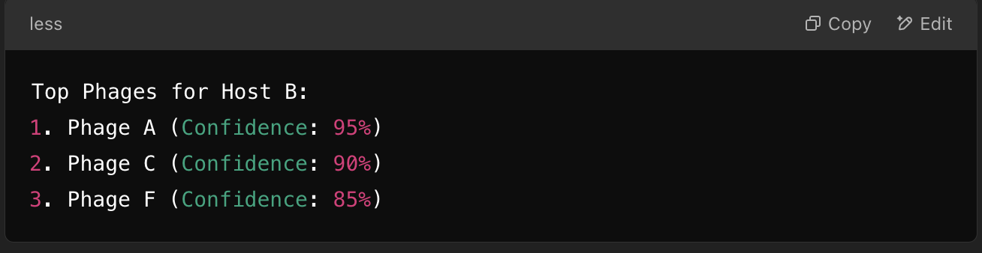
- Phage Cocktails:
  - Recommend combinations of phages for enhanced efficacy.
  - Example:
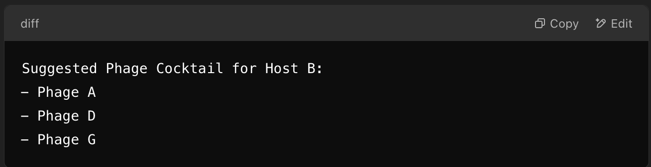

C. Supporting Data
- Feature Importance Scores:
  - Show which genomic, proteomic, or environmental features contributed to predictions.
  - Example:
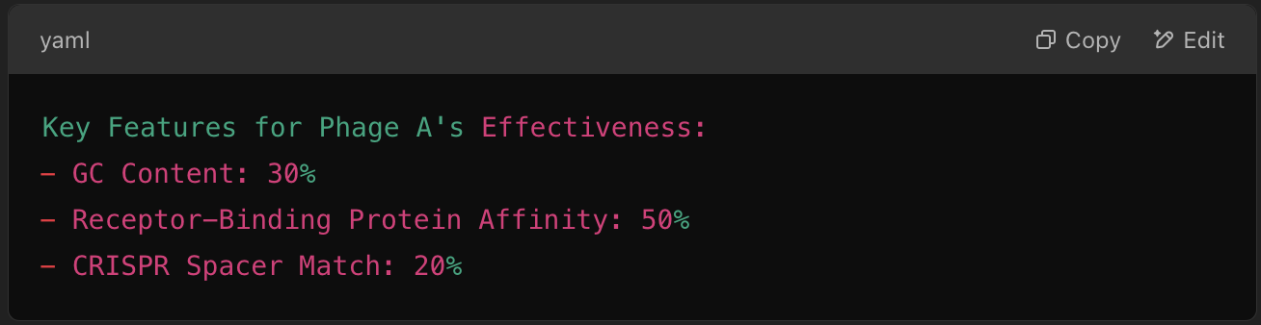
- Interaction Confidence:
  - Display detailed metrics such as k-mer similarity or sequence alignment scores.
  - Example:

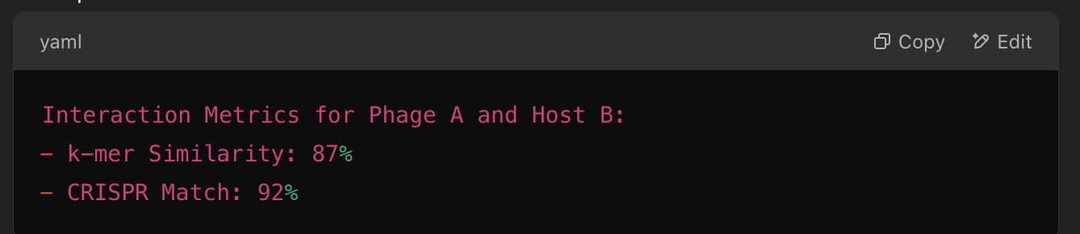

D. Real-Time Clinical Feedback
- Dynamic Updates:
  - Adapt outputs in real time as new input data (e.g., bacterial genomes) becomes available.
  - Example: "PhageMatch recommends Phage X for Host Y with 90% confidence based on updated metadata."
- Lytic vs. Lysogenic Profiles:
  - Differentiate outputs based on phage behavior.
  - Example:
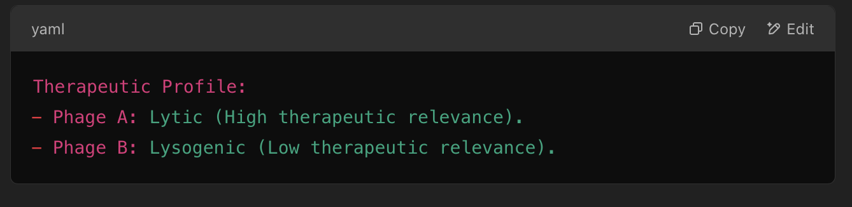

3. Output Formats

A. User-Friendly Formats
- Tabular Data:
  - Provide outputs in CSV or Excel formats for bulk processing.
  - Example:
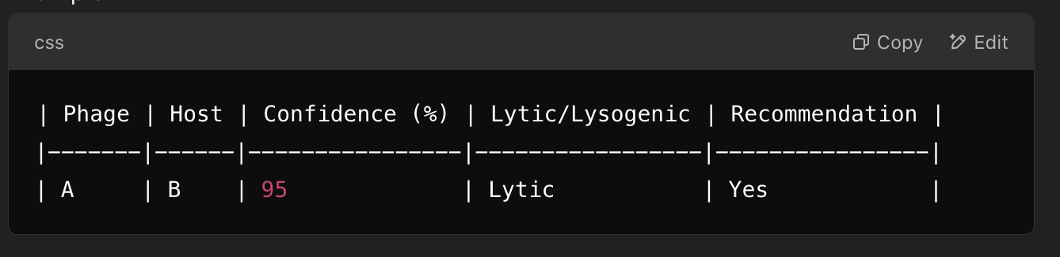
- Interactive Dashboards:
  - Develop web-based interfaces for visualization and exploration.
  - Example: A dashboard with filters for bacterial strain, geographic metadata, or genomic features.
- Visual Reports:
  - Generate detailed PDF summaries with charts and graphs.
  - Example: "A bar chart comparing efficacy metrics of top phages for multiple bacterial strains."

B. API Integration
- RESTful API:
  - Provide outputs in JSON or XML for seamless integration.
  - Example JSON Output:
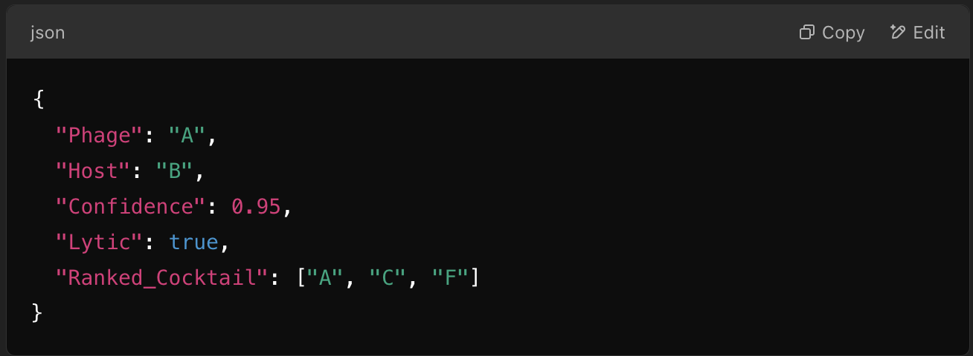

4. Explainability in Outputs

A. Feature Attribution
- Use tools like SHAP or LIME to visualize feature contributions.
  - Example: "Phage A was selected due to its high receptor-binding protein affinity and genomic similarity to Host B."
- Display feature importance scores in tabular or graphical form for each prediction.

B. Confidence and Uncertainty Estimates
- Include confidence intervals for predictions.
  - Example: "Phage X lyses Host Y with 85% confidence (+/- 5%)."
- Use visual aids like confidence bars or shaded areas on graphs to represent uncertainty.

5. Actionable Insights for Users

A. For Clinical Applications
- Therapeutic Potential:
  - Highlight lytic phages with high confidence scores.
  - Example: "Phage A is strongly recommended for clinical trials due to its lytic nature and 95% confidence score."
- Resistance Monitoring:
  - Flag bacterial strains with known resistance markers.
  - Example: "Host B contains phage-resistance genes. Consider multi-phage cocktails for treatment."

B. For Research Applications
- Hypothesis Generation:
  - Suggest untested phage-host pairs for experimental validation.
  - Example: "Phage Z is a novel candidate for Host Y with 87% predicted efficacy."
- Data Exploration:
  - Provide exploratory tools for analyzing correlations (e.g., k-mer similarity vs. efficacy).

6. Future Enhancements for Outputs
- Adaptive Outputs:
  - Incorporate real-time learning to update outputs as new datasets are added.
  - Example: "PhageMatch continuously improves predictions by integrating genomic updates and user feedback."
- Customizable Reports:
  - Allow users to select which data fields to include in the output.
- Global Accessibility:
  - Provide multilingual outputs to cater to a diverse user base.

7. Output Validation

A. Internal Validation:
- Compare outputs against benchmark datasets to ensure accuracy.
- Example: "PhageMatch achieved 95% accuracy in predicting interactions in a dataset of 1,000 phage-host pairs."

B. External Validation:
- Validate predictions through experimental trials.
- Example: "Phage A's predicted efficacy against Host B was confirmed in 92% of lab tests."

Conclusion
The output system for PhageMatch will deliver actionable, interpretable, and precise results tailored to both clinical and research needs. With real-time adaptability, robust validation, and advanced visualization options, these outputs will make PhageMatch an indispensable tool in phage-host interaction research and therapeutic applications.

